Travis Erwin
CS-340
Rolan Liwanag
04/09/2026

6-1 Milestone
Screenshot showing the table loaded, and managed to 10 results per page. 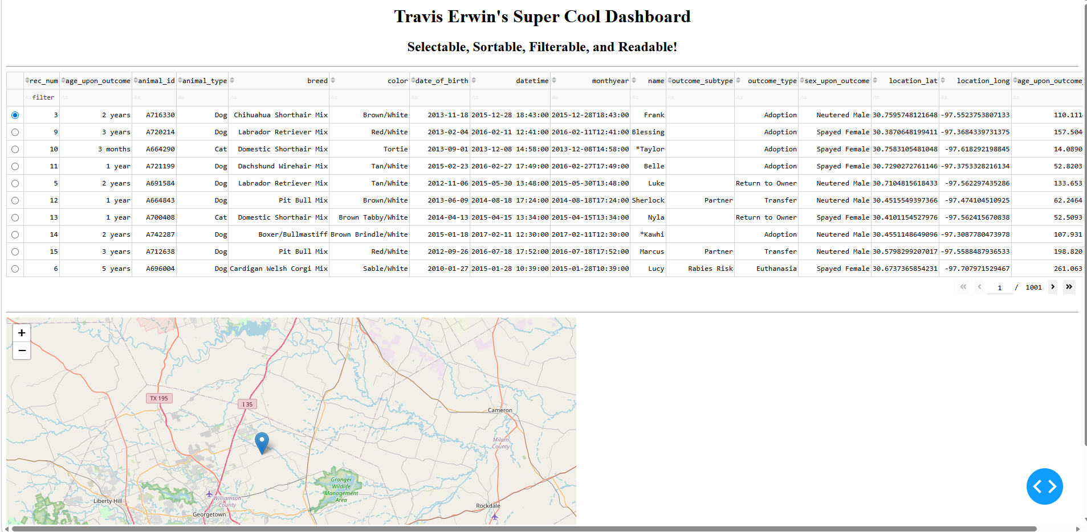
Screenshot showing results filtered by the animal “cat”. The filter option was made case insensitive for better usability. 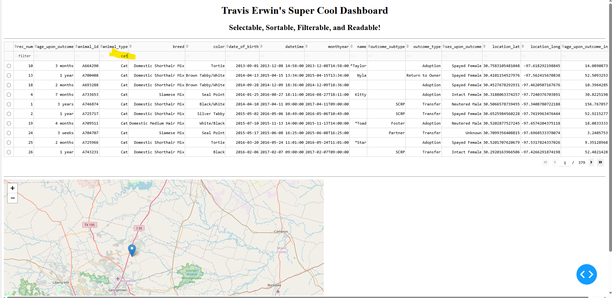
Table is multi-sortable, so you can sort age, animal, breed, name, etc all at once or separately if you like. 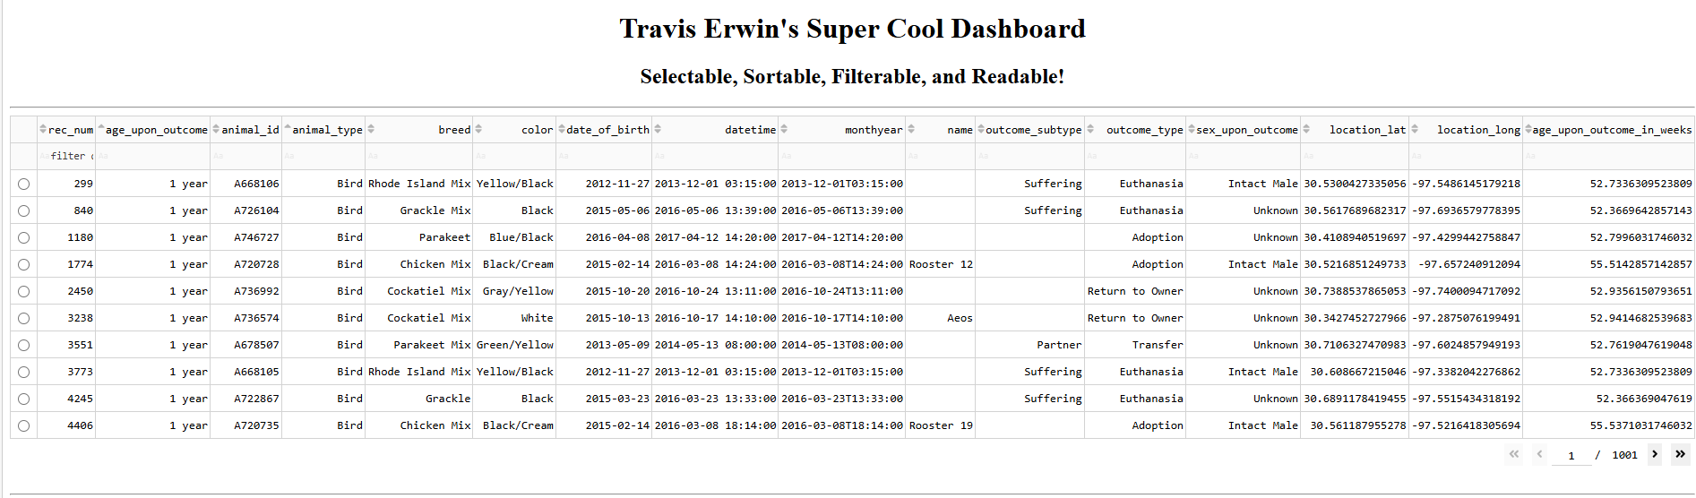
Animals are selectable by row and the location of where they were found is pinned on the map.
